Ex. No. 01 | WORKING WITH WIDGETS AND LAYOUTS
Date of Exercise | 25.08.2026
Git-hub Host Link | https://urk23cs1203.github.io/Flutter-Lap/

Aim:
To develop a Flutter application using basic widgets and layout widgets such as Container, Row, Column, Expanded, Card, and ListView.

Description:
This experiment demonstrates the development of a Flutter student profile/dashboard application using basic widgets and layout widgets.

The main concepts include:
- Flutter & Dart – Framework and programming language used.
- MaterialApp & Scaffold – Provide the basic application structure.
- StatelessWidget – Creates a non-changing user interface.
- AppBar – Displays the application title.
- Column & Row – Arrange widgets vertically and horizontally.
- Container – Provides padding, margin, and layout control.
- Icon – Displays graphical symbols.
- Card & ListTile – Display information in an organized format.
- ListView – Displays multiple items in a scrollable list.
- Alignment & Spacing – Controls the position and spacing of widgets.

Procedure:
Step 1: Open the Terminal and verify that Flutter is installed correctly by executing flutter doctor. Step 2: Check the available Android emulator or connected devices using flutter devices.
Step 3: Create a new Flutter project by executing flutter create widget_layout. Step 4: Navigate to the project directory using cd widget_layout.
Step 5: Open the project in Visual Studio Code using code ..
Step 6: Open the lib/main.dart file and remove the default Flutter code.
Step 7: Write the basic Flutter program using MaterialApp, Scaffold, and AppBar.
Step 8: Add a Column widget to arrange the student name, department, and laboratory details vertically.
Step 9: Add a Container widget and use padding and margin to organize the student profile section. Step 10: Add a Row widget and place Home, Person, and Settings icons horizontally.
Step 11: Add Card and ListTile widgets to display subject details such as Flutter and Mobile Application Development.
Step 12: Add a ListView widget to display multiple subjects in a scrollable list. Step 13: Save the main.dart file and execute flutter run in the Terminal.
Step 14: Observe and verify the completed Student Profile/Dashboard interface on the selected device.

1
Ex. 1 | Working with widgets and layouts

Program:
import 'package:flutter/material.dart'; void main() {
runApp(const MyApp());
}
class MyApp extends StatelessWidget { const MyApp({super.key}); @override
Widget build(BuildContext context) { return MaterialApp( debugShowCheckedModeBanner: false, theme: ThemeData(
primarySwatch: Colors.indigo, scaffoldBackgroundColor: Colors.grey[100], appBarTheme: const AppBarTheme( backgroundColor: Colors.indigo, foregroundColor: Colors.white,
),
),
home: const StudentProfile(),
);
}
}

class StudentProfile extends StatelessWidget { const StudentProfile({super.key});

@override
Widget build(BuildContext context) { return Scaffold(
appBar: AppBar( title: const Text( 'Student Profile',
style: TextStyle(fontWeight: FontWeight.bold),
),
centerTitle: true,
),

2
Ex. 1 | Working with widgets and layouts

body: ListView(
padding: const EdgeInsets.all(16), children: [
// Student Profile Container Container(
padding: const EdgeInsets.all(20)
margin: const EdgeInsets.only(bottom: 15), decoration: BoxDecoration(
color: Colors.indigo,
borderRadius: BorderRadius.circular(15), boxShadow: const [
BoxShadow(
color: Colors.grey, blurRadius: 6,
offset: Offset(0, 3),
),
],
),
child: const Column( children: [ CircleAvatar(
radius: 40,
backgroundColor: Colors.white, child: Icon(
Icons.person, size: 50,
color: Colors.indigo,
),
),

SizedBox(height: 12), Text(
'ARSATH AHAMED URK23CS1203',
style: TextStyle( color: Colors.white, fontSize: 25,
fontWeight: FontWeight.bold,
),
),

3
Ex. 1 | Working with widgets and layouts

SizedBox(height: 5), Text(
'Computer Science and Engineering', textAlign: TextAlign.center,
style: TextStyle(
color: Colors.white70, fontSize: 16,
),
),
SizedBox(height: 5), Text(
'Flutter Laboratory', style: TextStyle(
color: Colors.white70, fontSize: 15,
),
),
],
),
),

// Row with Icons Card(
elevation: 4,
shape: RoundedRectangleBorder( borderRadius: BorderRadius.circular(15),
),
child: Padding(
padding: const EdgeInsets.all(18), child: Row(
mainAxisAlignment: MainAxisAlignment.spaceEvenly, children: const [
Icon( Icons.home,
color: Colors.blue, size: 35,
),
Icon( Icons.person,
color: Colors.green, size: 35,
),

4
Ex. 1 | Working with widgets and layouts

Icon( Icons.settings,
color: Colors.orange, size: 35,
),
],
),
),
),
const SizedBox(height: 15),
// Section Title const Text( 'Subjects',
style: TextStyle( fontSize: 22,
fontWeight: FontWeight.bold, color: Colors.indigo,
),
),
const SizedBox(height: 10),

// Flutter Card Card( elevation: 4,
color: Colors.blue[50],
shape: RoundedRectangleBorder( borderRadius: BorderRadius.circular(15),
),
child: const ListTile( leading: CircleAvatar(
backgroundColor: Colors.blue, child: Icon(
Icons.book,
color: Colors.white,
),
),
title: Text( 'Fl
),

5
Ex. 1 | Working with widgets and layouts

utter',
style: TextStyle(
fontWeight: FontWeight.bold,
),
),
subtitle: Text(
'Mobile Application Development',
),
),
// Cloud Computing Card Card(
elevation: 4,
color: Colors.green[50],
shape: RoundedRectangleBorder( borderRadius: BorderRadius.circular(15),
),
child: const ListTile( leading: CircleAvatar(
backgroundColor: Colors.green, child: Icon(
Icons.cloud,
color: Colors.white,
),
),
title: Text(
'Cloud Computing', style: TextStyle(
fontWeight: FontWeight.bold,
),
),
subtitle: Text(
'Cloud Technologies and Services',
),
),
),
// Programming Card Card(
elevation: 4,
color: Colors.orange[50],
shape:

6
Ex. 1 | Working with widgets and layouts

RoundedRectangleBorder( borderRadius: BorderRadius.circular(15),
),
child: const ListTile( leading: CircleAvatar(
backgroundColor: Colors.orange, child: Icon(
Icons.code,
color: Colors.white,
),
),
title: Text( 'Programming', style: TextStyle(
fontWeight: FontWeight.bold,
),
),
subtitle: Text('Programming Fundamentals',
),
),
),
const SizedBox(height: 15),
// Bottom Message Container(
padding: const EdgeInsets.all(15), decoration: BoxDecoration( color: Colors.deepPurple,
borderRadius: BorderRadius.circular(12),
),
child: const Text(
'Welcome to Flutter Laboratory!', textAlign: TextAlign.center, style: TextStyle(
color: Colors.white, fontSize: 18,
fontWeight: FontWeight.bold,
),),),],),);}}

7
Ex. 1 | Working with widgets and layouts

Output:
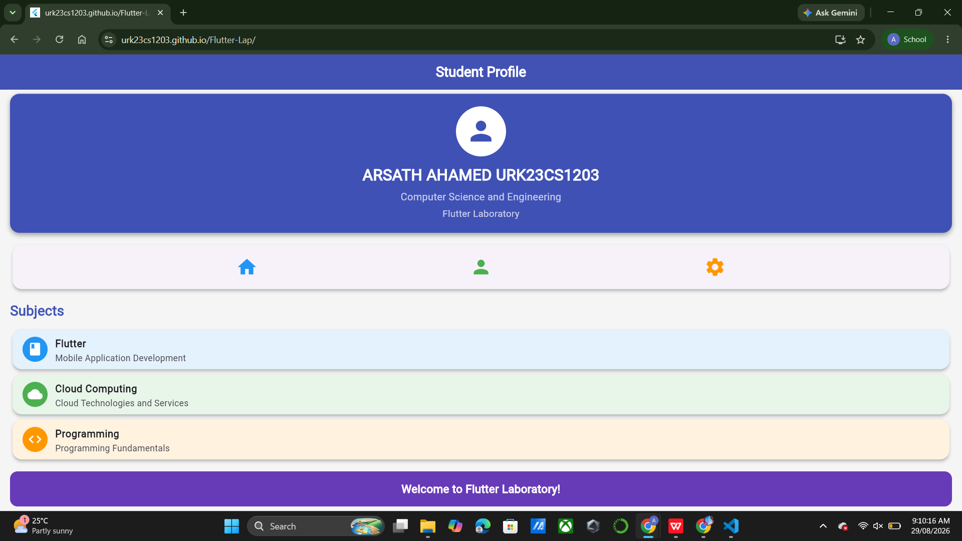

c

Result:
A Flutter student profile/dashboard interface was successfully developed using basic widgets and layout widgets.

8
Ex. 1 | Working with widgets and layouts

